ABSTRACT
Medicinal plants play a crucial role in traditional healthcare systems such as Ayurveda and Siddha, providing natural treatments for various ailments. Accurate identification of these plants is often difficult due to similarities in leaf appearance, environmental variations, and the lack of expert knowledge among the general public. To overcome these challenges, this project presents an automated medicinal plant identification system using deep learning techniques, aimed at simplifying plant recognition and preserving traditional medicinal knowledge.
The proposed system employs a Neural Architecture Search (NAS)–based convolutional neural network to classify medicinal plants from leaf images. Uploaded images are preprocessed through resizing, normalization, and color conversion before being analyzed by the trained model. The system predicts the plant species with a corresponding confidence score and delivers comprehensive information, including plant names, clinical benefits, and Ayurvedic uses in both English and Tamil. This bilingual approach improves accessibility and supports regional users in understanding medicinal properties.
The model demonstrates high accuracy and efficient performance compared to conventional CNN models. Integration with a Flask-based web application enables real-time predictions through a simple and user-friendly interface. By combining artificial intelligence with traditional herbal medicine, the proposed system contributes to digital healthcare awareness, supports educational and research activities, and promotes the conservation and proper utilization of medicinal plants

1. Introduction
Medicinal plants have been an essential component of traditional healthcare systems such as Ayurveda, Siddha, and Unani for thousands of years. These plants are widely recognized for their natural healing properties and are used in the treatment and prevention of numerous diseases, including liver disorders, diabetes, inflammation, and infections. In countries like India, medicinal plants continue to play a significant role in rural and primary healthcare. However, accurate identification of medicinal plants is critical, as incorrect usage or misidentification can reduce therapeutic effectiveness and may pose serious health risks.
In recent years, advances in artificial intelligence, particularly in the field of deep learning, have revolutionized image-based classification and pattern recognition tasks. Computer vision techniques using convolutional neural networks (CNNs) have shown promising results in plant and leaf classification. Despite this progress, traditional CNN architectures often require manual design and extensive experimentation to achieve optimal performance. Furthermore, variations in lighting conditions, background clutter, leaf orientation, and image quality introduce additional challenges, making plant identification a complex problem that demands robust and adaptive learning models.
To address these challenges, this project presents an automated medicinal plant identification system based on a Neural Architecture Search (NAS) model deployed through a Flask web application. The proposed system classifies medicinal plants from uploaded leaf images and provides informative outputs including plant names, confidence scores, clinical benefits, and Ayurvedic uses in both English and Tamil. The inclusion of bilingual information enhances accessibility and preserves indigenous medicinal knowledge. By integrating modern deep learning techniques with traditional healthcare knowledge, the system aims to support education, research, and awareness while promoting the conservation and responsible use of medicinal plant resources.

Problem Statement
Medicinal plants form a fundamental part of traditional healthcare systems such as Ayurveda and Siddha, offering natural and cost-effective remedies for a wide range of illnesses. Despite their importance, the accurate identification and proper utilization of medicinal plants remain a major challenge. Many medicinal plants share similar visual characteristics, especially in leaf shape, color, and texture, making it difficult for non-experts to distinguish between species. Misidentification can lead to incorrect treatment, reduced therapeutic effectiveness, or even adverse health effects.
Currently, medicinal plant identification relies heavily on botanical experts, field guides, or manual observation techniques, which are time-consuming, location-dependent, and often inaccessible to the general public. In rural areas and among students or beginners in herbal medicine, the lack of expert guidance further increases the risk of incorrect plant usage. Additionally, traditional identification methods do not scale well and fail to provide real-time assistance. With the gradual decline in traditional knowledge transfer between generations, valuable indigenous medicinal information is at risk of being lost.
Existing digital plant identification systems and mobile applications often use conventional convolutional neural networks, which require extensive manual tuning and may not generalize well across varying environmental conditions. Factors such as inconsistent lighting, background noise, leaf orientation, image resolution, and plant maturity significantly affect classification accuracy. Moreover, many existing systems focus solely on plant identification without offering detailed medicinal insights, and very few provide multilingual support tailored to regional users.
Therefore, there is a strong need for an intelligent, automated, and user-friendly system that can accurately identify medicinal plants from images while delivering reliable medicinal information in an accessible format. The system must be capable of handling real-world image variations, minimize dependency on expert knowledge, and preserve traditional medicinal wisdom. Addressing these challenges through advanced deep learning techniques and a web-based deployment forms the core problem addressed in this project.

2. Literature Survey
The identification and classification of medicinal plants have been widely studied using traditional botanical methods and, more recently, computational approaches. Early plant identification techniques primarily relied on manual observation of morphological features such as leaf shape, color, texture, venation, and flower structure. Although these methods are accurate when performed by experts, they are time-consuming, require extensive domain knowledge, and are not feasible for real-time or large-scale applications. This limitation motivated researchers to explore automated plant recognition systems using image processing and machine learning techniques.
Initial computational approaches employed hand-crafted feature extraction methods such as shape descriptors, color histograms, texture analysis using GLCM (Gray Level Co-occurrence Matrix), and edge detection techniques. These features were then classified using traditional machine learning algorithms such as Support Vector Machines (SVM), k-Nearest Neighbors (k-NN), Decision Trees, and Random Forests. While these methods achieved moderate accuracy under controlled conditions, their performance degraded significantly when applied to real-world images with varying illumination, background noise, and occlusion. Additionally, the reliance on manually designed features limited their adaptability and scalability.
With the advent of deep learning, convolutional neural networks (CNNs) emerged as a powerful solution for image-based plant classification. CNN-based models such as AlexNet, VGGNet, ResNet, and Inception demonstrated significant improvements in classification accuracy by automatically learning hierarchical features from raw images. Several studies applied these architectures to leaf-based medicinal plant datasets and reported promising results. Transfer learning further enhanced performance by leveraging pretrained models on large-scale image datasets. However, these architectures often require careful manual design, hyperparameter tuning, and substantial computational resources, making them less efficient for lightweight or real-time applications.
Recent research has focused on optimizing deep learning architectures to improve accuracy while reducing model complexity. Neural Architecture Search (NAS) has emerged as an advanced approach that automatically discovers optimal network structures tailored to specific tasks. NAS-based models eliminate the need for manual architecture design and have shown superior performance in various image classification domains, including plant disease detection and agricultural analysis. Despite their advantages, the application of NAS models in medicinal plant identification remains relatively unexplored, especially in systems designed for practical user interaction.
Several web-based and mobile applications have been developed for plant identification; however, many of these systems provide only plant names without offering detailed medicinal or clinical information. Furthermore, the majority of existing platforms lack multilingual support, limiting accessibility for regional users and rural communities. Very few systems integrate traditional medicinal knowledge such as Ayurvedic uses alongside modern clinical benefits. This highlights a significant research gap in combining accurate plant classification with comprehensive, user-friendly, and culturally relevant information delivery.
In summary, existing literature demonstrates significant progress in automated plant identification using deep learning techniques. However, challenges remain in achieving high accuracy under real-world conditions, reducing model complexity, preserving traditional medicinal knowledge, and enhancing accessibility through bilingual or multilingual interfaces. These limitations motivate the development of an intelligent medicinal plant identification system using NAS-based deep learning integrated with a web platform, as proposed in this project.

3 Objectives of the Proposed System
- To design and develop an automated medicinal plant identification system that accurately classifies different medicinal plant species using leaf images, thereby reducing human effort and minimizing errors caused by manual identification methods.
- To implement a Neural Architecture Search (NAS)–based deep learning model that automatically determines the most efficient neural network architecture for plant classification, ensuring improved accuracy and optimized performance compared to traditional convolutional neural networks.
- To enable non-expert users, including students, farmers, and traditional medicine practitioners, to identify medicinal plants easily without requiring prior botanical knowledge or expert assistance.
- To ensure robust system performance under real-world conditions by effectively handling variations in image quality, lighting, background clutter, leaf orientation, and plant maturity stages.
- To provide prediction confidence scores along with classification results, helping users assess the reliability and trustworthiness of the identified medicinal plant.
- To deliver comprehensive clinical information describing the health benefits and therapeutic properties of each identified medicinal plant in a clear and informative manner.
- To integrate Ayurvedic and traditional medicinal uses of plants within the system, supporting the preservation and digital documentation of indigenous healthcare knowledge.
- To support bilingual content delivery in both English and Tamil, improving system accessibility for regional users and enhancing understanding among diverse user groups.
- To design and deploy a user-friendly and responsive web application using the Flask framework, enabling real-time image uploads, fast predictions, and seamless user interaction.
- To promote awareness, education, and conservation of medicinal plant resources by combining modern artificial intelligence techniques with traditional healthcare practices for sustainable and responsible plant usage.

4 Scope of the Proposed System
- The proposed system is designed to accurately identify a predefined set of medicinal plant species using leaf images by applying advanced deep learning techniques.
- The system incorporates image preprocessing methods such as resizing, normalization, color space conversion, and handling of various image formats to improve model robustness.
- A Neural Architecture Search (NAS)–based deep learning model is employed to automatically select an optimized network architecture, enhancing classification accuracy and computational efficiency.
- The scope includes real-time image classification through a web-based interface, enabling users to upload plant images and obtain instant prediction results.
- The system provides detailed output information, including plant names, confidence scores, clinical benefits, and Ayurvedic uses, supporting informed understanding of medicinal properties.
- Bilingual content delivery in English and Tamil is integrated to ensure accessibility for regional users and preserve traditional medicinal knowledge.
- The application is designed to perform effectively under real-world conditions by addressing challenges such as background noise, lighting variations, and differences in leaf orientation.
- The system is deployed using the Flask framework, making it platform-independent and accessible across desktops, tablets, and mobile devices.
- The scope allows for future expansion of the dataset and inclusion of additional medicinal plant species without significant modification to the existing system architecture.
- The proposed system serves as a foundational platform for future enhancements, including mobile application development, multi-language support, integration with IoT-based plant monitoring systems, and advanced healthcare advisory features.

5 System Requirements

1. Hardware Requirements
- Personal Computer or Laptop for development and testing
- Processor: Intel Core i5 or higher (or equivalent AMD processor)
- RAM: Minimum 8 GB (16 GB recommended for model training)
- Storage: Minimum 256 GB Hard Disk or SSD
- GPU (Optional but Recommended): NVIDIA GPU with CUDA support for faster model training
- Webcam or Camera Device (Optional) for capturing plant images
- Internet Connection for downloading libraries and model files
- Display Monitor with minimum resolution of 1366 × 768
- Keyboard and Mouse for user interaction
- Power Supply suitable for continuous system operation

2. Software Requirements
- Operating System: Windows 10 / Linux / macOS
- Programming Language: Python 3.8 or above
- Deep Learning Framework: TensorFlow and Keras
- Web Framework: Flask
- Image Processing Libraries: OpenCV, Pillow (PIL), NumPy
- Machine Learning Utilities: Scikit-learn
- Frontend Technologies: HTML, CSS, JavaScript
- Development Environment: VS Code / PyCharm / Jupyter Notebook
- Dataset: Medicinal plant leaf image dataset
- Web Browser: Google Chrome / Mozilla Firefox / Microsoft Edge

6 Existing System
The existing systems for medicinal plant identification are largely based on traditional botanical practices and limited computational techniques. Identification is typically carried out through manual inspection of morphological features such as leaf shape, size, color, venation patterns, and texture, which requires extensive botanical expertise and field experience. While this method can be accurate, it is time-consuming, labor-intensive, and not easily accessible to non-experts or rural users. Some modern approaches utilize basic image processing and conventional machine learning algorithms, where handcrafted features are extracted and classified using methods such as Support Vector Machines or k-Nearest Neighbors. However, these systems often perform well only under controlled conditions and fail to generalize to real-world environments with variations in lighting, background clutter, image resolution, and leaf orientation. Additionally, most existing solutions provide only plant identification without offering detailed clinical benefits, traditional medicinal uses, or multilingual support. The lack of real-time capability, limited scalability, and dependency on expert knowledge significantly reduce the practicality and usability of existing medicinal plant identification systems.

7 Disadvantages of Existing System
- The existing system relies heavily on expert botanical knowledge and manual observation, making it difficult for non-experts, students, and rural users to accurately identify medicinal plants.
- Traditional and basic digital identification methods are time-consuming and do not support real-time plant recognition, limiting their practicality in field conditions.
- Conventional image processing and machine learning approaches depend on handcrafted features, which often fail to handle variations in lighting, background, image quality, and leaf orientation.
- Most existing systems provide only plant identification results and lack detailed information such as clinical benefits, Ayurvedic uses, and multilingual support, reducing user understanding and usability.
- The scalability of existing systems is limited, as expanding to include more plant species or adapting to new environments requires significant manual effort and redesign.

8 Proposed System
The proposed system introduces an intelligent and automated medicinal plant identification solution using advanced deep learning techniques integrated with a web-based application. The system employs a Neural Architecture Search (NAS)–based model to accurately classify medicinal plants from leaf images by automatically optimizing the network architecture for improved performance and reliability. Uploaded images are preprocessed through resizing, normalization, and color conversion to handle real-world variations in image quality and environmental conditions. Upon successful classification, the system provides detailed output including the plant name, prediction confidence score, clinical benefits, and Ayurvedic uses in both English and Tamil, ensuring accessibility for diverse user groups. The Flask-based web interface enables real-time image upload and prediction through a user-friendly and platform-independent environment. By reducing dependency on expert knowledge and combining modern artificial intelligence with traditional medicinal information, the proposed system enhances healthcare awareness, supports education and research, and promotes the conservation and responsible utilization of medicinal plant resources.

9 Advantages of the Proposed System
- Accurate and Reliable Identification: The system utilizes a Neural Architecture Search (NAS)–based deep learning model, which ensures high accuracy in identifying medicinal plants even under challenging conditions such as varying lighting, backgrounds, or leaf orientations. This reduces errors compared to traditional or manual identification methods.
- Time-Efficient and Real-Time Processing: By automating the plant recognition process, the system significantly reduces the time and effort required for identification. Users can obtain real-time predictions by simply uploading leaf images through the web application, eliminating the need for expert consultation.
- Comprehensive Medicinal Information: Beyond plant identification, the system provides detailed clinical benefits and Ayurvedic uses for each plant. This feature educates users about the therapeutic properties of plants and bridges the gap between modern AI and traditional medicinal knowledge.
- Bilingual Support and Accessibility: The inclusion of English and Tamil languages ensures accessibility for regional users, students, and practitioners. This bilingual support helps preserve indigenous knowledge while making the system usable by a wider audience.
- Scalable and User-Friendly Design: The Flask-based web application offers a simple, responsive, and platform-independent interface. The system is also scalable, allowing the addition of new plant species, multi-language support, and future integration with mobile applications or advanced healthcare advisory features.

Workflow Diagram –

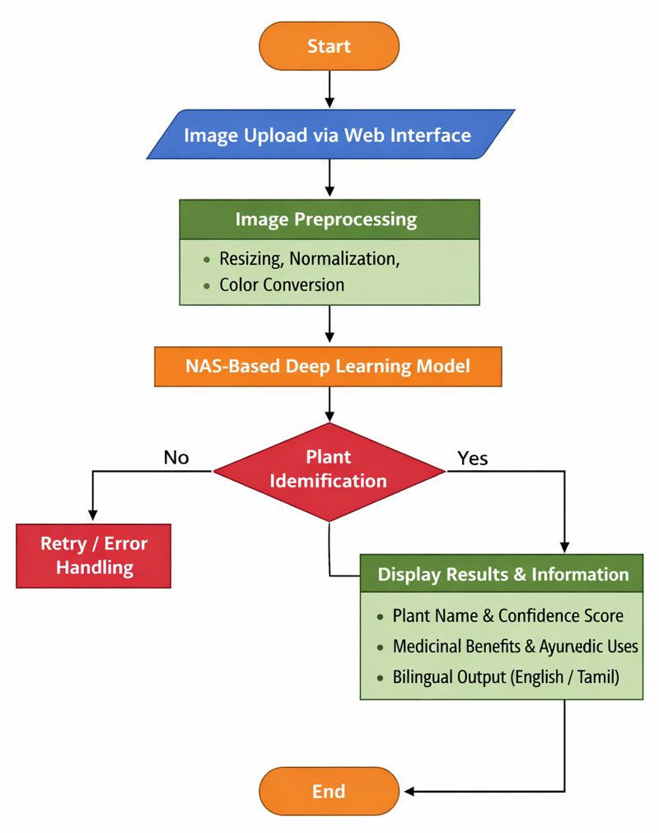

Block Diagram –

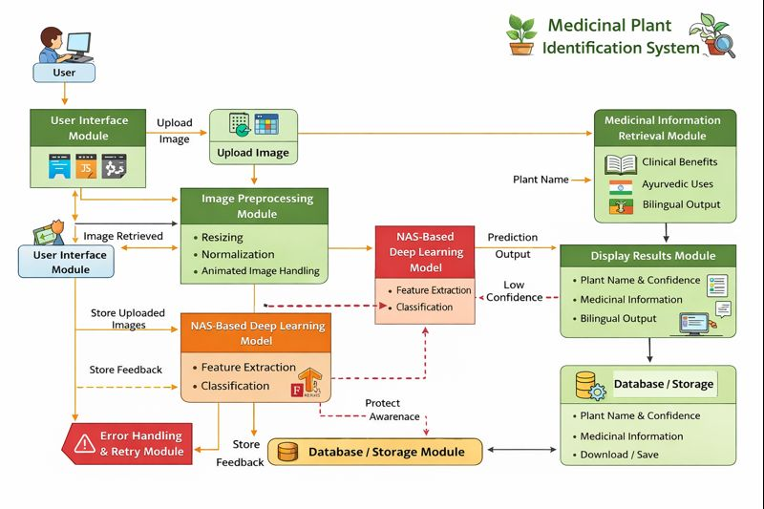

Architecture Diagram –

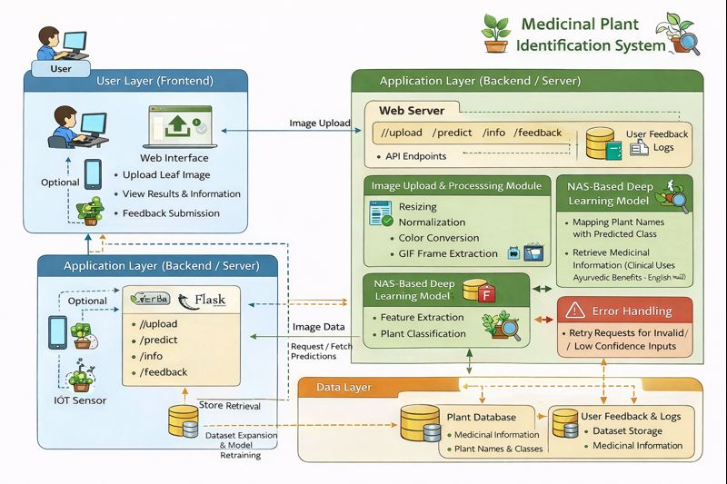

Modules and Descriptions
The proposed system is divided into several interconnected modules, each performing specific tasks to ensure accurate identification of medicinal plants and delivery of relevant medicinal information. The modules are as follows:

1. User Interface Module
The User Interface (UI) module serves as the primary point of interaction between the user and the system. Developed using HTML, CSS, and JavaScript, and integrated into the Flask web framework, this module provides a simple, intuitive, and responsive interface that allows users to upload leaf images, view results, and navigate through additional plant information. The UI ensures accessibility across devices, including desktops, laptops, and mobile devices. The design emphasizes clarity, ease of navigation, and multilingual support, offering information in both English and Tamil. This module also handles input validation, ensuring that the uploaded files are in the correct image formats (JPEG, PNG, or GIF) and within acceptable size limits. Error messages and guidance prompts are displayed in real time to enhance user experience. Furthermore, the UI module incorporates a feedback mechanism where users can submit queries or report misclassification, which is valuable for continuous system improvement.

2. Image Upload Module
This module allows users to upload leaf images to the system through the web interface. It is responsible for receiving the image from the client-side, temporarily storing it in the server directory, and preparing it for preprocessing. The module includes file validation checks to ensure that only image files of supported formats are accepted. Additionally, the module checks for image integrity, confirming that the uploaded file is not corrupted. To improve system performance, the module may also implement size limitations and optional image compression for large files. The uploaded image is then passed to the next module (Image Preprocessing) for transformation into a format suitable for the deep learning model. Security measures, such as sanitization of file names and prevention of malicious uploads, are also part of this module to ensure safe system operation.

3. Image Preprocessing Module
The Image Preprocessing module is a critical component that transforms raw input images into a format suitable for deep learning analysis. This module performs several key tasks:
- Resizing: Converts all uploaded images to a fixed size matching the input dimensions of the NAS-based model, ensuring uniformity and efficient computation.
- Normalization: Scales pixel values to a standard range (usually 0–1), which accelerates training convergence and improves model prediction accuracy.
- Color Conversion: Converts images to RGB format, ensuring compatibility with the model, even if the original image is grayscale or uses other color formats.
- Animated Image Handling: Detects and extracts the first frame from animated GIFs to maintain compatibility with the model.
- Noise Reduction and Enhancement (Optional): Applies filtering techniques to remove background noise and enhance leaf features, improving feature extraction during model prediction.
This module ensures that the deep learning model receives high-quality and standardized input, which directly affects the accuracy and reliability of plant identification.

4. Neural Architecture Search (NAS) Model Module
The core of the system, the NAS-based deep learning model module, is responsible for identifying the plant species from the preprocessed image. NAS is an advanced approach that automatically searches for the optimal neural network architecture for a given task, reducing manual tuning and improving performance. This module performs the following functions:
- Feature Extraction: Automatically learns hierarchical features from leaf images, capturing critical information such as shape, texture, venation patterns, and color gradients.
- Classification: Utilizes a fully connected layer at the output to classify the image into one of the predefined medicinal plant categories.
- Confidence Scoring: Computes a probability distribution over all plant classes and outputs the confidence score for the predicted plant, helping users assess prediction reliability.
- Optimization: Uses backpropagation and gradient descent to optimize model weights during training, ensuring high accuracy and generalization for new images.
The NAS model is particularly advantageous because it can adaptively find the best combination of layers, kernel sizes, and connections for the medicinal plant dataset, providing superior performance compared to manually designed CNN architectures.

5. Plant Identification Module
This module receives the model’s output and performs final plant identification. It maps the predicted class index to the corresponding plant name using a predefined dictionary. Additionally, this module verifies the confidence score; if the score is below a certain threshold, it triggers an error handling or retry mechanism, prompting the user to upload a clearer image. This ensures that low-confidence predictions do not mislead users. The module also records prediction logs, including timestamps, plant classes, and confidence scores, which can be useful for system evaluation and dataset expansion in future versions.

6. Medicinal Information Retrieval Module
Once the plant is identified, this module retrieves detailed medicinal information for the predicted plant. It accesses predefined dictionaries containing:
- Clinical Benefits: Provides scientific information about the health effects of the plant, such as liver protection, anti-inflammatory properties, or cognitive enhancement.
- Ayurvedic Uses: Includes traditional uses of the plant in Ayurveda, linking it to specific treatments or Rasayana benefits.
- Bilingual Support: Ensures that all information is available in both English and Tamil, preserving indigenous knowledge and improving regional accessibility.
The module formats the information for display, ensuring clarity, readability, and proper alignment on the web interface.

7. Display Results Module
The Display Results module is responsible for presenting the prediction and associated information to the user. It organizes the output into distinct sections: plant name, confidence score, clinical benefits, Ayurvedic uses, and bilingual content. The module supports responsive design to adjust the layout for different screen sizes and devices. Additionally, it may offer options for users to download the results or save images for future reference. By providing an intuitive and comprehensive display, this module enhances user engagement and ensures that the system is educational, informative, and user-friendly.

8. Error Handling and Retry Module
To maintain robustness, the system includes an Error Handling and Retry module. This module monitors the system for potential issues, such as invalid image uploads, unsupported file formats, low-confidence predictions, or system processing errors. When an error occurs, it provides clear messages to guide users in correcting the problem and may suggest steps to improve image quality for better predictions. This module ensures the reliability of the system, prevents crashes, and enhances user trust.

9. Database / Storage Module
Although the system primarily uses dictionaries for medicinal information, a storage module can be implemented for future scalability. This module stores:
- Uploaded Images: For dataset expansion or retraining the model.
- Prediction Logs: Including user inputs, model outputs, and confidence scores for analysis and improvement.
- User Feedback: To record misclassifications or suggestions, aiding in continuous system enhancement.
A database-backed module ensures long-term sustainability, supports analytics, and allows incremental updates without affecting the core system functionality.

10. System Integration Module
The System Integration module ensures seamless communication between all the above modules. It manages the workflow from image upload to preprocessing, model prediction, information retrieval, and result display. It coordinates the sequence of operations, handles exceptions, and maintains smooth data flow between frontend (UI) and backend (Flask + NAS model). This module ensures that the system operates as a cohesive whole, providing real-time, reliable, and user-friendly plant identification services.
SOFTWARE DESCRIPTION
Python
Python is a general-purpose interpreted, interactive, object-oriented, and high-level programming language. It was created by Guido van Rossum during 1985- 1990. Like Perl, Python source code is also available under the GNU General Public License (GPL). This tutorial gives enough understanding on Python programming language.
Python is a popular programming language. It was created in 1991 by Guido van Rossum.
It is used for:
- web development (server-side),
- software development,
- mathematics,
- System scripting.
Python can be used on a server to create web applications. Python can be used alongside software to create workflows. Python can connect to database systems. It can also read and modify files. Python can be used to handle big data and perform complex mathematics. Python can be used for rapid prototyping, or for production-ready software development.
Python works on different platforms (Windows, Mac, Linux, Raspberry Pi, etc). Python has a simple syntax similar to the English language. Python has syntax that allows developers to write programs with fewer lines than some other programming languages.
Python runs on an interpreter system, meaning that code can be executed as soon as it is written. This means that prototyping can be very quick. Python can be treated in a procedural way, an object-orientated way or a functional way.
Python is a high-level, interpreted, interactive and object-oriented scripting language. Python is designed to be highly readable. It uses English keywords frequently where as other languages use punctuation, and it has fewer syntactical constructions than other languages.
- Python is Interpreted − Python is processed at runtime by the interpreter. You do not need to compile your program before executing it. This is similar to PERL and PHP.
- Python is Interactive − you can actually sit at a Python prompt and interact with the interpreter directly to write your programs.
- Python is Object-Oriented − Python supports Object-Oriented style or technique of programming that encapsulates code within objects.
- Python is a Beginner's Language − Python is a great language for the beginner-level programmers and supports the development of a wide range of applications from simple text processing to WWW browsers to games.

History of Python
Python was developed by Guido van Rossum in the late eighties and early nineties at the National Research Institute for Mathematics and Computer Science in the Netherlands.
Python is derived from many other languages, including ABC, Modula-3, C, C++, Algol-68, SmallTalk, and Unix shell and other scripting languages.
Python is copyrighted. Like Perl, Python source code is now available under the GNU General Public License (GPL).
Python is now maintained by a core development team at the institute, although Guido van Rossum still holds a vital role in directing its progress.

Python Features
Python's features include −
- Easy-to-learn − Python has few keywords, simple structure, and a clearly defined syntax. This allows the student to pick up the language quickly.
- Easy-to-read − Python code is more clearly defined and visible to the eyes.
- Easy-to-maintain − Python's source code is fairly easy-to-maintain.
- A broad standard library − Python's bulk of the library is very portable and cross-platform compatible on UNIX, Windows, and Macintosh.
- Interactive Mode − Python has support for an interactive mode which allows interactive testing and debugging of snippets of code.
- Portable − Python can run on a wide variety of hardware platforms and has the same interface on all platforms.
- Extendable − you can add low-level modules to the Python interpreter. These modules enable programmers to add to or customize their tools to be more efficient.
- Databases − Python provides interfaces to all major commercial databases.
- GUI Programming − Python supports GUI applications that can be created and ported to many system calls, libraries and windows systems, such as Windows MFC, Macintosh, and the X Window system of Unix.
- Scalable − Python provides a better structure and support for large programs than shell scripting.
Apart from the above-mentioned features, Python has a big list of good features, few are listed below −
- It supports functional and structured programming methods as well as OOP.
- It can be used as a scripting language or can be compiled to byte-code for building large applications.
- It provides very high-level dynamic data types and supports dynamic type checking.
- It supports automatic garbage collection.
- It can be easily integrated with C, C++, COM, ActiveX, CORBA, and Java.
Python is available on a wide variety of platforms including Linux and Mac OS X.

Python Syntax compared to other programming languages
- Python was designed to for readability, and has some similarities to the English language with influence from mathematics.
- Python uses new lines to complete a command, as opposed to other programming languages which often use semicolons or parentheses.
- Python relies on indentation, using whitespace, to define scope; such as the scope of loops, functions and classes. Other programming languages often use curly-brackets for this purpose.

Features of Python

Simple
Python is a simple and minimalistic language. Reading a good Python program feels almost like reading English, although very strict English! This pseudo-code nature of Python is one of its greatest strengths. It allows you to concentrate on the solution to the problem rather than the language itself.

Easy to Learn
As you will see, Python is extremely easy to get started with. Python has an extraordinarily simple syntax, as already mentioned.

Free and Open Source
Python is an example of a FLOSS (Free/Libré and Open Source Software). In simple terms, you can freely distribute copies of this software, read its source code, make changes to it, and use pieces of it in new free programs. FLOSS is based on the concept of a community which shares knowledge. This is one of the reasons why Python is so good - it has been created and is constantly improved by a community who just want to see a better Python.

High-level Language
When you write programs in Python, you never need to bother about the low-level details such as managing the memory used by your program, etc.

Portable
Due to its open-source nature, Python has been ported to (i.e. changed to make it work on) many platforms. All your Python programs can work on any of these platforms without requiring any changes at all if you are careful enough to avoid any system-dependent features.
You can use Python on GNU/Linux, Windows, FreeBSD, Macintosh, Solaris, OS/2, Amiga, AROS, AS/400, BeOS, OS/390, z/OS, Palm OS, QNX, VMS, Psion, Acorn RISC OS, VxWorks, PlayStation, Sharp Zaurus, Windows CE and PocketPC!
You can even use a platform like Kivy to create games for your computer and for iPhone, iPad, and Android.

Interpreted
This requires a bit of explanation.
A program written in a compiled language like C or C++ is converted from the source language i.e. C or C++ into a language that is spoken by your computer (binary code i.e. 0s and 1s) using a compiler with various flags and options. When you run the program, the linker/loader software copies the program from hard disk to memory and starts running it.
Python, on the other hand, does not need compilation to binary. You just run the program directly from the source code. Internally, Python converts the source code into an intermediate form called bytecodes and then translates this into the native language of your computer and then runs it. All this, actually, makes using Python much easier since you don't have to worry about compiling the program, making sure that the proper libraries are linked and loaded, etc. This also makes your Python programs much more portable, since you can just copy your Python program onto another computer and it just works!

Object Oriented
Python supports procedure-oriented programming as well as object-oriented programming. In procedure-oriented languages, the program is built around procedures or functions which are nothing but reusable pieces of programs. In object-oriented languages, the program is built around objects which combine data and functionality. Python has a very powerful but simplistic way of doing OOP, especially when compared to big languages like C++ or Java.

Extensible
If you need a critical piece of code to run very fast or want to have some piece of algorithm not to be open, you can code that part of your program in C or C++ and then use it from your Python program.

Embeddable
You can embed Python within your C/C++ programs to give scripting capabilities for your program's users.

Extensive Libraries
The Python Standard Library is huge indeed. It can help you do various things involving regular expressions, documentation generation, unit testing, threading, databases, web browsers, CGI, FTP, email, XML, XML-RPC, HTML, WAV files, cryptography, GUI (graphical user interfaces), and other system-dependent stuff. Remember, all this is always available wherever Python is installed. This is called the Batteries Included philosophy of Python.
Besides the standard library, there are various other high-quality libraries which you can find at the Python Package Index.

Summary
Python is indeed an exciting and powerful language. It has the right combination of performance and features that make writing programs in Python both fun and easy.

Python 3 versus 2
You can ignore this section if you're not interested in the difference between "Python version 2" and "Python version 3". But please do be aware of which version you are using. This book is written for Python version 3.
Remember that once you have properly understood and learn to use one version, you can easily learn the differences and use the other one. The hard part is learning programming and understanding the basics of Python language itself. That is our goal in this book, and once you have achieved that goal, you can easily use Python 2 or Python 3 depending on your situation.
What makes Python so special? How does it happen that programmers, young and old, experienced and novice, want to use it? How did it happen that large companies adopted Python and implemented their flagship products using it?
There are many reasons – we’ve listed some of them already, but let’s enumerate them again in a more practical manner:
- it’s easy to learn – the time needed to learn Python is shorter than for many other languages; this means that it’s possible to start the actual programming faster;
- it’s easy to teach – the teaching workload is smaller than that needed by other languages; this means that the teacher can put more emphasis on general (language-independent) programming techniques, not wasting energy on exotic tricks, strange exceptions and incomprehensible rules;
- it’s easy to use for writing new software – it’s often possible to write code faster when using Python;
- it’s easy to understand – it’s also often easier to understand someone else’s code faster if it is written in Python;
- it’s easy to obtain, install and deploy – Python is free, open and multiplatform; not all languages can boast that.
Anaconda
Anaconda is the most popular python data science platform.

Anaconda Distribution
With over 6 million users, the open source Anaconda Distribution is the fastest and easiest way to do Python and R data science and machine learning on Linux, Windows, and Mac OS X. It's the industry standard for developing, testing, and training on a single machine.

Anaconda Enterprise
Anaconda Enterprise is an AI/ML enablement platform that empowers organizations to develop, govern, and automate AI/ML and data science from laptop through training to production. It lets organizations scale from individual data scientists to collaborative teams of thousands, and to go from a single server to thousands of nodes for model training and deployment.
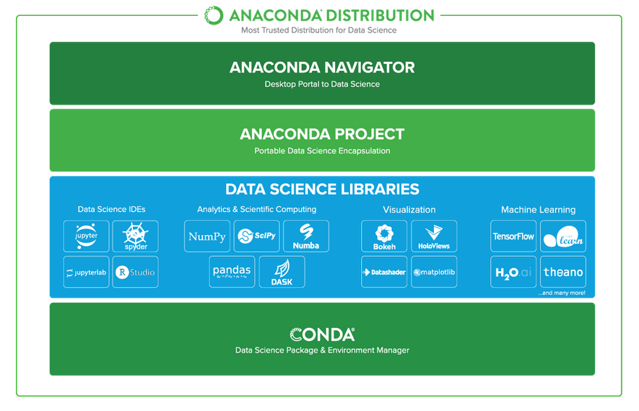

Anaconda Data Science Libraries
- Over 1,400 Anaconda-curated and community data science packages
- Develop data science projects using your favourite IDEs, including Jupyter, JupyterLab, Spyder, and RStudio
- Analyse data with scalability and performance with Dask, numpy, pandas, and Numba
- Visualize your data with Matplotlib, Bokeh, Datashader, and Holoviews
- Create machine learning and deep learning models with Scikit-learn, Tensorflow, h20, and Theano
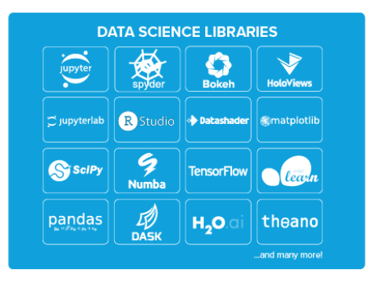

Conda, the Data Science Package & Environment Manager
- Automatically manages all packages, including cross-language dependencies
- Works across all platforms: Linux, macOS, Windows
- Create virtual environments
- Download conda packages from Anaconda, Anaconda Enterprise, Conda Forge, and Anaconda Cloud
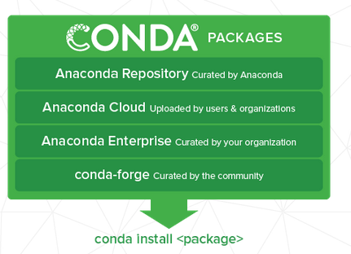

Anaconda Navigator, the Desktop Portal to Data Science
- Install and launch applications and editors including Jupyter, RStudio, Visual Studio Code, and Spyder
- Manage your local environments and data science projects from a graphical interface
- Connect to Anaconda Cloud or Anaconda Enterprise
- Access the latest learning and community resources

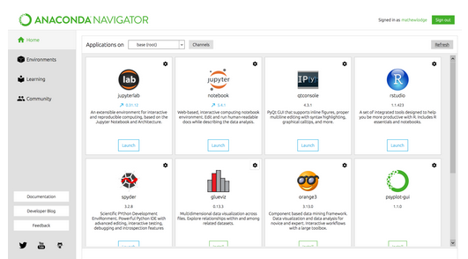

Spyder
Spyder is an open source cross-platform integrated development environment (IDE) for scientific programming in the Python language. ... Initially created and developed by Pierre Raybaut in 2009, since 2012 Spyder has been maintained and continuously improved by a team of scientific Python developers and the community. Strongly recommend the free, open-source Spyder Integrated Development Environment (IDE) for scientific and engineering programming, due to its integrated editor, interpreter console, and debugging tools. Spyder is included in Anaconda and other distributions.
Spyder is a powerful scientific environment written in Python, for Python, and designed by and for scientists, engineers and data analysts. It offers a unique combination of the advanced editing, analysis, debugging, and profiling functionality of a comprehensive development tool with the data exploration, interactive execution, deep inspection, and beautiful visualization capabilities of a scientific package.
Beyond its many built-in features, its abilities can be extended even further via its plugin system and API. Furthermore, Spyder can also be used as a PyQt5 extension library, allowing developers to build upon its functionality and embed its components, such as the interactive console, in their own PyQt software.

Editor
Work efficiently in a multi-language editor with a function/class browser, code analysis tools, automatic code completion, horizontal/vertical splitting, and go-to-definition.

IPython Console
Harness the power of as many IPython consoles as you like within the flexibility of a full GUI interface; run your code by line, cell, or file; and render plots right inline.

Variable Explorer
Interact with and modify variables on the fly: plot a histogram or time series, edit a date frame or Numpy array, sort a collection, dig into nested objects, and more!

Profiler
Find and eliminate bottlenecks to unchain your code's performance.

Debugger
Trace each step of your code's execution interactively.

Help
Instantly view any object's docs, and render your own.

FEASIBILITY STUDY
The feasibility study is carried out to test whether the proposed system is worth being implemented. The proposed system will be selected if it is best enough in meeting the performance requirements.
The feasibility carried out mainly in three sections namely.
• Economic Feasibility
• Technical Feasibility
• Behavioral Feasibility
Economic Feasibility
Economic analysis is the most frequently used method for evaluating effectiveness of the proposed system. More commonly known as cost benefit analysis. This procedure determines the benefits and saving that are expected from the system of the proposed system. The hardware in system department if sufficient for system development.
Technical Feasibility
This study center around the system’s department hardware, software and to what extend it can support the proposed system department is having the required hardware and software there is no question of increasing the cost of implementing the proposed system. The criteria, the proposed system is technically feasible and the proposed system can be developed with the existing facility.
Behavioral Feasibility
People are inherently resistant to change and need sufficient amount of training, which would result in lot of expenditure for the organization. The proposed system can generate reports with day-to-day information immediately at the user’s request, instead of getting a report, which doesn’t contain much detail.
System Implementation
Implementation of software refers to the final installation of the package in its real environment, to the satisfaction of the intended users and the operation of the system. The people are not sure that the software is meant to make their job easier.
- The active user must be aware of the benefits of using the system
- Their confidence in the software built up
- Proper guidance is impaired to the user so that he is comfortable in using the application
Before going ahead and viewing the system, the user must know that for viewing the result, the server program should be running in the server. If the server object is not running on the server, the actual processes will not take place.
User Training
To achieve the objectives and benefits expected from the proposed system it is essential for the people who will be involved to be confident of their role in the new system. As system becomes more complex, the need for education and training is more and more important. Education is complementary to training. It brings life to formal training by explaining the background to the resources for them. Education involves creating the right atmosphere and motivating user staff. Education information can make training more interesting and more understandable.
Training on the Application Software
After providing the necessary basic training on the computer awareness, the users will have to be trained on the new application software. This will give the underlying philosophy of the use of the new system such as the screen flow, screen design, type of help on the screen, type of errors while entering the data, the corresponding validation check at each entry and the ways to correct the data entered. This training may be different across different user groups and across different levels of hierarchy.
Operational Documentation
Once the implementation plan is decided, it is essential that the user of the system is made familiar and comfortable with the environment. A documentation providing the whole operations of the system is being developed. Useful tips and guidance is given inside the application itself to the user. The system is developed user friendly so that the user can work the system from the tips given in the application itself.
System Maintenance
The maintenance phase of the software cycle is the time in which software performs useful work. After a system is successfully implemented, it should be maintained in a proper manner. System maintenance is an important aspect in the software development life cycle. The need for system maintenance is to make adaptable to the changes in the system environment. There may be social, technical and other environmental changes, which affect a system which is being implemented. Software product enhancements may involve providing new functional capabilities, improving user displays and mode of interaction, upgrading the performance characteristics of the system. So only thru proper system maintenance procedures, the system can be adapted to cope up with these changes. Software maintenance is of course, far more than “finding mistakes”.
Corrective Maintenance
The first maintenance activity occurs because it is unreasonable to assume that software testing will uncover all latent errors in a large software system. During the use of any large program, errors will occur and be reported to the developer. The process that includes the diagnosis and correction of one or more errors is called Corrective Maintenance.
Adaptive Maintenance
The second activity that contributes to a definition of maintenance occurs because of the rapid change that is encountered in every aspect of computing. Therefore Adaptive maintenance termed as an activity that modifies software to properly interfere with a changing environment is both necessary and commonplace.
Perceptive Maintenance
The third activity that may be applied to a definition of maintenance occurs when a software package is successful. As the software is used, recommendations for new capabilities, modifications to existing functions, and general enhancement are received from users. To satisfy requests in this category, Perceptive maintenance is performed. This activity accounts for the majority of all efforts expended on software maintenance.

Preventive Maintenance
The fourth maintenance activity occurs when software is changed to improve future maintainability or reliability, or to provide a better basis for future enhancements. Often called preventive maintenance, this activity is characterized by reverse engineering and re-engineering techniques
TESTING OF PRODUCT
Testing of Product
System testing is the stage of implementation, which aimed at ensuring that system works accurately and efficiently before the live operation commence. Testing is the process of executing a program with the intent of finding an error. A good test case is one that has a high probability of finding an error. A successful test is one that answers a yet undiscovered error.
Testing is vital to the success of the system. System testing makes a logical assumption that if all parts of the system are correct, the goal will be successfully achieved. The candidate system is subject to variety of tests-on-line response, Volume Street, recovery and security and usability test. A series of tests are performed before the system is ready for the user acceptance testing. Any engineered product can be tested in one of the following ways. Knowing the specified function that a product has been designed to from, test can be conducted to demonstrate each function is fully operational. Knowing the internal working of a product, tests can be conducted to ensure that “al gears mesh”, that is the internal operation of the product performs according to the specification and all internal components have been adequately exercised.
UNIT TESTING
Unit testing is the testing of each module and the integration of the overall system is done. Unit testing becomes verification efforts on the smallest unit of software design in the module. This is also known as ‘module testing’. The modules of the system are tested separately. This testing is carried out during the programming itself. In this testing step, each model is found to be working satisfactorily as regard to the expected output from the module. There are some validation checks for the fields. For example, the validation check is done for verifying the data given by the user where both format and validity of the data entered is included. It is very easy to find error and debug the system.
INTEGRATION TESTING
Data can be lost across an interface, one module can have an adverse effect on the other sub function, when combined, may not produce the desired major function. Integrated testing is systematic testing that can be done with sample data. The need for the integrated test is to find the overall system performance. There are two types of integration testing. They are:
- Top-down integration testing.
- Bottom-up integration testing.
WHITE BOX TESTING
White Box testing is a test case design method that uses the control structure of the procedural design to drive cases. Using the white box testing methods, we derived test cases that guarantee that all independent paths within a module have been exercised at least once.
BLACK BOX TESTING
- Black box testing is done to find incorrect or missing function
- Interface error
- Errors in external database access
- Performance errors
- Initialization and termination errors
In ‘functional testing’, is performed to validate an application conforms to its specifications of correctly performs all its required functions. So this testing is also called ‘black box testing’. It tests the external behaviour of the system. Here the engineered product can be tested knowing the specified function that a product has been designed to perform, tests can be conducted to demonstrate that each function is fully operational.
VALIDATION TESTING
After the culmination of black box testing, software is completed assembly as a package, interfacing errors have been uncovered and corrected and final series of software validation tests begin validation testing can be defined as many, but a single definition is that validation succeeds when the software functions in a manner that can be reasonably expected by the customer.

USER ACCEPTANCE TESTING
User acceptance of the system is the key factor for the success of the system. The system under consideration is tested for user acceptance by constantly keeping in touch with prospective system at the time of developing changes whenever required.

OUTPUT TESTING
After performing the validation testing, the next step is output asking the user about the format required testing of the proposed system, since no system could be useful if it does not produce the required output in the specific format. The output displayed or generated by the system under consideration. Here the output format is considered in two ways. One is screen and the other is printed format. The output format on the screen is found to be correct as the format was designed in the system phase according to the user needs. For the hard copy also output comes out as the specified requirements by the user. Hence the output testing does not result in any connection in the system.
System Implementation
Implementation of software refers to the final installation of the package in its real environment, to the satisfaction of the intended users and the operation of the system. The people are not sure that the software is meant to make their job easier.
- The active user must be aware of the benefits of using the system
- Their confidence in the software built up
- Proper guidance is impaired to the user so that he is comfortable in using the application
Before going ahead and viewing the system, the user must know that for viewing the result, the server program should be running in the server. If the server object is not running on the server, the actual processes will not take place.
User Training
To achieve the objectives and benefits expected from the proposed system it is essential for the people who will be involved to be confident of their role in the new system. As system becomes more complex, the need for education and training is more and more important. Education is complementary to training. It brings life to formal training by explaining the background to the resources for them. Education involves creating the right atmosphere and motivating user staff. Education information can make training more interesting and more understandable.

Training on the Application Software
After providing the necessary basic training on the computer awareness, the users will have to be trained on the new application software. This will give the underlying philosophy of the use of the new system such as the screen flow, screen design, type of help on the screen, type of errors while entering the data, the corresponding validation check at each entry and the ways to correct the data entered. This training may be different across different user groups and across different levels of hierarchy.
Operational Documentation
Once the implementation plan is decided, it is essential that the user of the system is made familiar and comfortable with the environment. A documentation providing the whole operations of the system is being developed. Useful tips and guidance is given inside the application itself to the user. The system is developed user friendly so that the user can work the system from the tips given in the application itself.

System Maintenance
The maintenance phase of the software cycle is the time in which software performs useful work. After a system is successfully implemented, it should be maintained in a proper manner. System maintenance is an important aspect in the software development life cycle. The need for system maintenance is to make adaptable to the changes in the system environment. There may be social, technical and other environmental changes, which affect a system which is being implemented. Software product enhancements may involve providing new functional capabilities, improving user displays and mode of interaction, upgrading the performance characteristics of the system. So only thru proper system maintenance procedures, the system can be adapted to cope up with these changes. Software maintenance is of course, far more than “finding mistakes”.

Corrective Maintenance
The first maintenance activity occurs because it is unreasonable to assume that software testing will uncover all latent errors in a large software system. During the use of any large program, errors will occur and be reported to the developer. The process that includes the diagnosis and correction of one or more errors is called Corrective Maintenance.
Adaptive Maintenance
The second activity that contributes to a definition of maintenance occurs because of the rapid change that is encountered in every aspect of computing. Therefore Adaptive maintenance termed as an activity that modifies software to properly interfere with a changing environment is both necessary and commonplace.
Perceptive Maintenance
The third activity that may be applied to a definition of maintenance occurs when a software package is successful. As the software is used, recommendations for new capabilities, modifications to existing functions, and general enhancement are received from users. To satisfy requests in this category, Perceptive maintenance is performed. This activity accounts for the majority of all efforts expended on software maintenance.
Preventive Maintenance
The fourth maintenance activity occurs when software is changed to improve future maintainability or reliability, or to provide a better basis for future enhancements. Often called preventive maintenance, this activity is characterized by reverse engineering and re-engineering techniques

Types of Software Testing
Ad-hoc testing
This type of software testing is very informal and unstructured and can be performed by any stakeholder with no reference to any test case or test design documents. The person performing Ad-hoc testing has a good understanding of the domain and workflows of the application to try to find defects and break the software. Ad-hoc testing is intended to find defects that were not found by existing test cases.
Acceptance Testing
Acceptance testing is a formal type of software testing that is performed by end user when the features have been delivered by developers. The aim of this testing is to check if the software confirms to their business needs and to the requirements provided earlier. Acceptance tests are normally documented at the beginning of the sprint (in agile) and is a means for testers and developers to work towards a common understanding and shared business domain knowledge.
Accessibility Testing
In accessibility testing, the aim of the testing is to determine if the contents of the website can be easily accessed by disable people. Various checks such as color and contrast (for color blind people), font size for visually impaired, clear and concise text that is easy to read and understand.
Agile Testing
Agile Testing is a type of software testing that accommodates agile software development approach and practices. In an Agile development environment, testing is an integral part of software development and is done along with coding. Agile testing allows incremental and iterative coding and testing.
API Testing
API testing is a type of testing that is similar to unit testing. Each of the Software APIs are tested as per API specification. API testing is mostly done by testing team unless APIs to be tested or complex and needs extensive coding. API testing requires understanding both API functionality and possessing good coding skills.
Automated testing
This is a testing approach that makes use of testing tools and/or programming to run the test cases using software or custom developed test utilities. Most of the automated tools provided capture and playback facility, however there are tools that require writing extensive scripting or programming to automate test cases.
All Pairs testing
Also known as Pair wise testing, is a black box testing approach and a testing method where in for each input is tested in pairs of inputs, which helps to test software works as expected with all possible input combinations.
Beta Testing
This is a formal type of software testing that is carried out by end customers before releasing or handing over software to end users. Successful completion of Beta testing means customer acceptance of the software.

Black Box testing
Black box testing is a software testing method where in testers are not required to know coding or internal structure of the software. Black box testing method relies on testing software with various inputs and validating results against expected output.
Backward Compatibility Testing
Type of software testing performed to check newer version of the software can work successfully installed over previous version of the software and newer version of the software works as fine with table structure, data structures, files that were created by previous version of the software.
Boundary Value Testing (BVT)
Boundary Value Testing is a testing technique that is based on concept “error aggregates at boundaries”. In this testing technique, testing is done extensively to check for defects at boundary conditions. If a field accepts value 1 to 100 then testing is done for values 0, 1, 2, 99, 100 and 101.
Big Bang Integration testing
This is one of the integration testing approaches, in Big Bang integration testing all or all most all of the modules are developed and then coupled together.
Bottom up Integration testing
Bottom up integration testing is an integration testing approach where in testing starts with smaller pieces or sub systems of the software till all the way up covering entire software system. Bottom up integration testing begins with smaller portion of the software and eventually scale up in terms of size, complexity and completeness.
Branch Testing
Is a white box testing method for designing test cases to test code for every branching condition? Branch testing method is applied during unit testing.
Browser compatibility Testing
It is one of the sub types of testing of compatibility testing performed by testing team. Browser compatibility testing is performed for web applications with combination of different browsers and operating systems.
Compatibility testing
Compatibility testing is one of the test types performed by testing team. Compatibility testing checks if the software can be run on different hardware, operating system, bandwidth, databases, web servers, application servers, hardware peripherals, emulators, different configuration, processor, different browsers and different versions of the browsers etc.
Component Testing
This type of software testing is performed by developers. Component testing is carried out after completing unit testing. Component testing involves testing a group of units as code together as a whole rather than testing individual functions, methods.
Condition Coverage Testing
Condition coverage testing is a testing technique used during unit testing, where in developer tests for all the condition statements like if, if else, case etc., in the code being unit tested.
Dynamic Testing
Testing can be performed as Static Testing and Dynamic testing, Dynamic testing is a testing approach where-in testing can be done only by executing code or software are classified as Dynamic Testing. Unit testing, Functional testing, regression testing, performance testing etc.
Decision Coverage Testing
Is a testing technique that is used in Unit testing, objective of decision coverage testing is to expertise and validate each and every decisions made in the code e.g. if, if else, case statements.
End-to-end Testing
End to end testing is performed by testing team, focus of end to end testing is to test end to end flows e.g. right from order creation till reporting or order creation till item return etc. and checking. End to end testing is usually focused mimicking real life scenarios and usage. End to end testing involves testing information flow across applications.

Exploratory Testing
Exploratory testing is an informal type of testing conducted to learn the software at the same time looking for errors or application behaviour that seems non-obvious. Exploratory testing is usually done by testers but can be done by other stake holders as well like Business Analysts, developers, end users etc. who are interested in learning functions of the software and at the same time looking for errors or behaviour is seems non-obvious.

Equivalence Partitioning
Equivalence partitioning is also known as Equivalence Class Partitioning is a software testing technique and not a type of testing by itself. Equivalence partitioning technique is used in black box and grey box testing types. Equivalence partitioning classifies test data into Equivalence classes as positive Equivalence classes and negative Equivalence classes, such classification ensures both positive and negative conditions are tested.
Functional Testing
Functional testing is a formal type of testing performed by testers. Functional testing focuses on testing software against design document, Use cases and requirements document. Functional testing is a black box type of testing and does not require internal working of the software unlike white box testing.

Fuzz Testing
Fuzz testing or fuzzing is a software testing technique that involves testing with unexpected or random inputs. Software is monitored for failures or error messages that are presented due to the input errors.
GUI (Graphical User Interface) testing
This type of software testing is aimed at testing the software GUI (Graphical User Interface) of the software meets the requirements as mentioned in the GUI mock-ups and Detailed designed documents. For e.g. checking the length and capacity of the input fields provided on the form, type of input field provided, e.g. some of the form fields can be displayed as dropdown box or a set of radio buttons. So GUI testing ensures GUI elements of the software are as per approved GUI mock-ups, detailed design documents and functional requirements. Most of the functional test automation tools work on GUI capture and playback capabilities. This makes script recording faster at the same time increases the effort on script maintenance.
Glass box Testing
Glass box testing is another name for White box testing. Glass box testing is a testing method that involves testing individual statements, functions etc., Unit testing is one of the Glass box testing methods.
Gorilla Testing
This type of software testing is done by software testing team, has a scary name though? Objective of Gorilla Testing is to exercise one or few functionality thoroughly or exhaustively by having multiple people test the same functionality.

Happy Path Testing
Also known as Golden path testing, this type of testing focuses on selective execution of tests that do not exercise the software for negative or error conditions.
Integration Testing
Integration testing also known as met in short, in one of the important types of software testing. Once the individual units or components are tested by developers as working then testing team will run tests that will test the connectivity among these units/component or multiple units/components. There are different approaches for Integration testing namely, Top-down integration testing, Bottom-up integration testing and a combination of these two known as Sand witch testing.

Interface Testing
Software provides support for one or more interfaces like “Graphical user interface”, “Command Line Interface” or “Application programming interface” to interact with its users or other software. Interfaces serves as medium for software to accept input from user and provide result. Approach for interface testing depends on the type of the interface being testing like GUI or API or CLI.
Internationalization Testing
Internationalization testing is a type of testing that is performed by software testing team to check the extent to which software can support Internationalization i.e., usage of different languages, different character sets, double byte characters etc., For e.g.: Gmail, is a web application that is used by people all over work with different languages, single by or multi byte character sets.
Keyword-driven Testing
Keyword driver testing is more of an automated software testing approach than a type of testing itself. Keyword driven testing is known as action driven testing or table driven testing.
Load Testing
Load testing is a type of non-functional testing; load testing is done to check the behaviour of the software under normal and over peak load conditions. Load testing is usually performed using automated testing tools. Load testing intends to find bottlenecks or issues that prevent software from performing as intended at its peak workloads.

Localization Testing
Localization testing a type of software testing performed by software testers, in this type of testing, software is expected to adapt to a particular locale, it should support a particular locale/language in terms of display, accepting input in that particular locale, display, font, date time, currency etc., related to a particular locale. For e.g. many web applications allow choice of locale like English, French, German or Japanese. So once locale is defined or set in the configuration of software, software is expected to work as expected with a set language/locale.

Negative Testing
This type of software testing approach, which calls out the “attitude to break”, these are functional and non-functional tests that are intended to break the software by entering incorrect data like incorrect date, time or string or upload binary file when text files supposed to be upload or enter huge text string for input fields etc. It is also a positive test for an error condition.
Non-functional testing
Software are built to fulfil functional and non-functional requirements, non-functional requirements like performance, usability, localization etc., There are many types of testing like compatibility testing, compliance testing, localization testing, usability testing, volume testing etc., that are carried out for checking non-functional requirements.

Pair Testing
It is a software testing technique that can be done by software testers, developers or Business analysts (BA). As the name suggests, two people are paired together, one to test and other to monitor and record test results. Pair testing can also be performed in combination of tester-developer, tester-business analyst or developer-business analyst combination. Combining testers and developers in pair testing helps to detect defects faster, identify root cause, fix and test the fix.
Performance Testing
It is a type of software testing and part of performance engineering that is performed to check some of the quality attributes of software like Stability, reliability, availability. Performance testing is carried out by performance engineering team. Unlike Functional testing, Performance testing is done to check non-functional requirements. Performance testing checks how well software works in anticipated and peak workloads. There are different variations or sub types of performance like load testing, stress testing, volume testing, soak testing and configuration testing.
Penetration Testing
It is a type of security testing, also known as pen test in short. Penetration testing is done to tests how secure software and its environments (Hardware, Operating system and network) are when subject to attack by an external or internal intruder. Intruder can be a human/hacker or malicious programs. Pen test uses methods to forcibly intrude (by brute force attack) or by using a weakness (vulnerability) to gain access to a software or data or hardware with an intent to expose ways to steal, manipulate or corrupt data, software files or configuration. Penetration Testing is a way of ethical hacking, an experienced Penetration tester will use the same methods and tools that a hacker would use but the intention of Penetration tester is to identify vulnerability and get them fixed before a real hacker or malicious program exploits it.

Regression Testing
It is a type of software testing that is carried out by software testers as functional regression tests and developers as Unit regression tests. Objective of regression tests are to find defects that got introduced to defect fix (is) or introduction of new feature(s). Regression tests are ideal candidate for automation.
Retesting
It is a type of retesting that is carried out by software testers as a part of defect fix verification. For e.g. a tester is verifying a defect fix and let us say that there are 3 test cases failed due to this defect. Once tester verifies defect fix as resolved, test will retest or test the same functionality again by executing the test cases that were failed earlier.
Risk based Testing
It is a type of software testing and a different approach towards testing a software. In Risk based testing, requirements and functionality of software to be tested are prioritized as Critical, High, Medium and low. In this approach, all critical and high priority tests are tested and them followed by Medium. Low priority or low risk functionality are tested at the end or may not base on the time available for testing.

Smoke testing
It is a type of testing that is carried out by software testers to check if the new build provided by development team is stable enough i.e., major functionality is working as expected in order to carry out further or detailed testing. Smoke testing is intended to find “show stopper” defects that can prevent testers from testing the application in detail. Smoke testing carried out for a build is also known as build verification test.
Security Testing
It is a type of software testing carried out by specialized team of software testers. Objective of security testing is to secure the software is to external or internal threats from humans and malicious programs. Security testing basically checks, how good is software’s authorization mechanism, how strong is authentication, how software maintains confidentiality of the data, how does the software maintain integrity of the data, what is the availability of the software in an event of an attack on the software by hackers and malicious programs is for Security testing requires good knowledge of application, technology, networking, security testing tools. With increasing number of web applications necessarily of security testing has increased to a greater extent.
Sanity Testing
It is a type of testing that is carried out mostly by testers and in some projects by developers as well. Sanity testing is a quick evaluation of the software, environment, network, external systems are up & running, software environment as a whole is stable enough to proceed with extensive testing. Sanity tests are narrow and most of the time sanity tests are not documented.

Scalability Testing
It is a non-functional test intended to test one of the software quality attributes i.e. “Scalability”. Scalability test is not focused on just one or few functionality of the software instead performance of software as a whole. Scalability testing is usually done by performance engineering team. Objective of scalability testing is to test the ability of the software to scale up with increased users, increased transactions, increase in database size etc., It is not necessary that software’s performance increases with increase in hardware configuration, scalability tests helps to find out how much more workload the software can support with expanding user base, transactions, data storage etc.,
Stability Testing
It is a non-functional test intended to test one of the software quality attributes i.e. “Stability”. Stability testing focuses on testing how stable software is when it is subject to loads at acceptable levels, peak loads, loads generated in spikes, with more volumes of data to be processed. Scalability testing will involve performing different types of performance tests like load testing, stress testing, spike testing, soak testing, spike testing etc.…
Static Testing is a form of testing where in approaches like reviews, walkthroughs are employed to evaluate the correctness of the deliverable. In static testing software code is not executed instead it is reviewed for syntax, commenting, naming convention, size of the functions and methods etc. Static testing usually has check lists against which deliverables are evaluated. Static testing can be applied for requirements, designs, and test cases by using approaches like reviews or walkthroughs.
Stress Testing is a type of performance testing, in which software is subjected to peak loads and even to a break point to observe how the software would behave at breakpoint. Stress testing also tests the behaviour of the software with insufficient resources like CPU, Memory, Network bandwidth, Disk space etc. Stress testing enables to check some of the quality attributes like robustness and reliability.

Conclusion
The proposed Medicinal Plant Identification System successfully demonstrates the integration of advanced artificial intelligence techniques with traditional medicinal knowledge to create an intelligent, accurate, and user-friendly solution. By leveraging a Neural Architecture Search (NAS)–based deep learning model, the system is capable of automatically identifying medicinal plants from leaf images with high accuracy and reliability. The image preprocessing module ensures that the system can handle real-world variations such as differing lighting conditions, backgrounds, leaf orientations, and animated image formats, thereby enhancing the robustness and practical usability of the system. The incorporation of confidence scores allows users to understand the reliability of predictions, making the system trustworthy for both novice and expert users.
In addition to plant identification, the system provides comprehensive medicinal information including clinical benefits and Ayurvedic uses, delivered in both English and Tamil. This bilingual support preserves indigenous knowledge and makes the system accessible to a wider audience, including students, researchers, farmers, and traditional practitioners. The Flask-based web application ensures a responsive and interactive interface, allowing real-time image upload, prediction, and information retrieval. Furthermore, the database and storage module provides scalability and supports future enhancements such as the addition of more plant species, multi-language support, mobile application integration, and advanced healthcare advisory features.
Overall, the proposed system bridges the gap between modern technology and traditional healthcare by providing a reliable, scalable, and informative platform for medicinal plant identification. It reduces dependency on expert knowledge, saves time, and enhances the understanding of medicinal properties of plants. By combining artificial intelligence, deep learning, and web-based technology, the system not only contributes to healthcare awareness and education but also promotes conservation and responsible utilization of medicinal plant resources. This project serves as a foundational model for future research and development in intelligent plant identification systems, demonstrating the potential of AI to complement and enhance traditional knowledge systems.

References
- K. Simonyan and A. Zisserman, “Very Deep Convolutional Networks for Large-Scale Image Recognition,” International Conference on Learning Representations (ICLR), 2015.
- C. Szegedy et al., “Going Deeper with Convolutions,” IEEE Conference on Computer Vision and Pattern Recognition (CVPR), 2015.
- K. He, X. Zhang, S. Ren, and J. Sun, “Deep Residual Learning for Image Recognition,” IEEE Conference on Computer Vision and Pattern Recognition (CVPR), 2016.
- L. Xie et al., “Neural Architecture Search with Reinforcement Learning,” arXiv preprint arXiv:1707.07012, 2017.
- B. Zoph and Q. V. Le, “Neural Architecture Search with Reinforcement Learning,” International Conference on Learning Representations (ICLR), 2017.
- F. Chollet, “Xception: Deep Learning with Depthwise Separable Convolutions,” IEEE Conference on Computer Vision and Pattern Recognition (CVPR), 2017.
- S. R. Singh, F. L. Koch, and D. T. Nguyen, “Plant Leaf Recognition Using Convolutional Neural Networks,” International Journal of Computer Applications, vol. 178, no. 11, pp. 18–22, 2019.
- A. M. Barriga et al., “Deep Learning for Plant Species Classification,” Computers and Electronics in Agriculture, vol. 167, 2020.
- Y. LeCun, Y. Bengio, and G. Hinton, “Deep Learning,” Nature, vol. 521, pp. 436–444, 2015.
- J. P. Wäldchen and P. Mäder, “Machine Learning for Image-Based Species Identification,” Methods in Ecology and Evolution, vol. 10, no. 4, pp. 546–559, 2019.
- P. Pham et al., “Efficient Neural Architecture Search via Parameter Sharing,” International Conference on Machine Learning (ICML), 2018.
- A. Krizhevsky, I. Sutskever, and G. E. Hinton, “ImageNet Classification with Deep Convolutional Neural Networks,” Advances in Neural Information Processing Systems (NeurIPS), 2012.
- M. S. Hussain et al., “Image Based Plant Classification Using Convolutional Neural Networks,” International Journal of Advanced Computer Science and Applications (IJACSA), vol. 10, no. 2, 2019.
- S. Kamilaris and F. X. Prenafeta-Boldú, “Deep Learning in Agriculture: A Survey,” Computers and Electronics in Agriculture, vol. 147, pp. 70–90, 2018.
- I. Goodfellow, Y. Bengio, and A. Courville, Deep Learning, MIT Press, 2016.

